Galaxy Sentiment Analysis Results
Out of the box distribution for Galaxy phones is interesting. The distribution of semtiment results suggest a generally favorable opinion of the Galaxy phones with far more (60% strongly positive – 5) versus not a favorable opinion (13% strongly negative). Since the results are skewed so far to the left or right, we can conclude the sentiments 1-4, while important are low in magnitude, relatively speaking – so on the whole, people really like the Samsumg phone products.
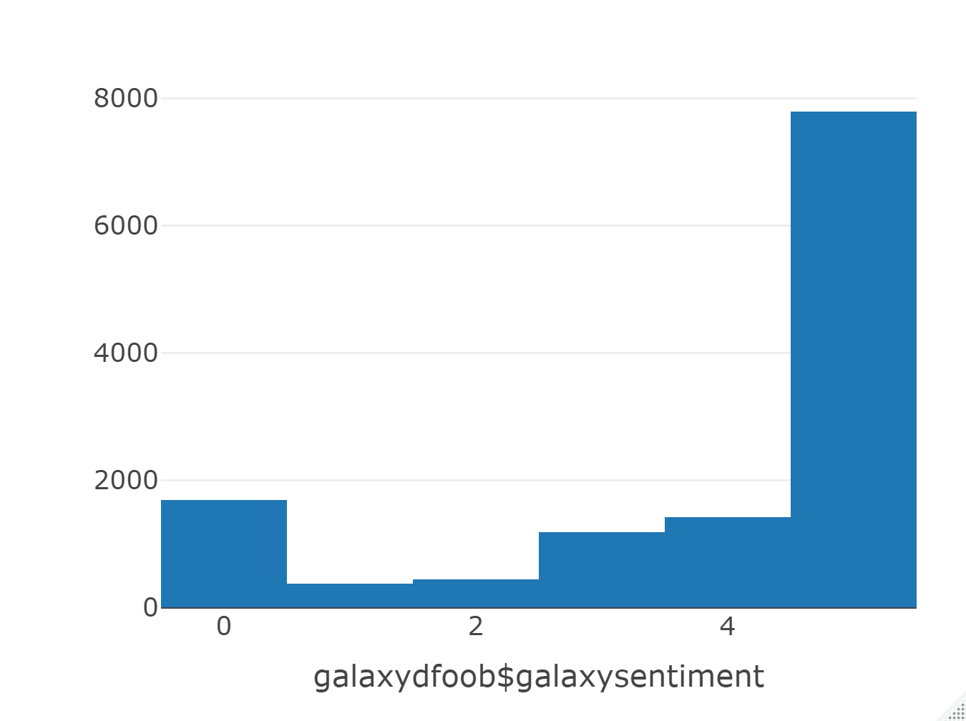

Using this information, I ran the out of the box data set for the Galaxy sentiment analysis researched by your team, and referred to as the small matrix data set evaluating whether or not I can generate a reliabel algorithm for sentiment prediction on a much larger data set. Out of the box, I was able to achieve better than 76% accuracy, with an average level of confidence in that result with the C5.0 algorithm.
Galaxy Out of the Box Results:
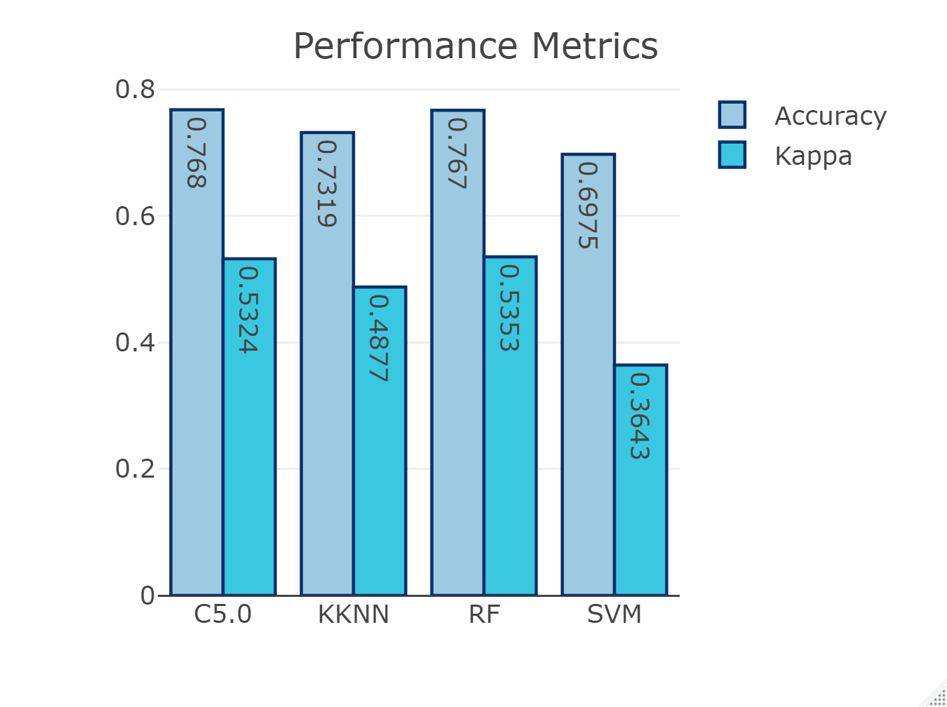

Next, I the manipulated the data by removing all attributes with near zero variance, meaning there was very little impact these attributes should have on the outcome. Removing these attributes from the calculation improves perfromance and ensures there is no needless impact, even small, from attributes that are deemed to statistically have little to no impact of the outcome.
Running the same four machine learning algorithms on the Galaxy small data set with attributes with near zero variance yielded a 76% accuracy with confidence above 53% with the same algorithm, C5.0
Galaxy NZV Results
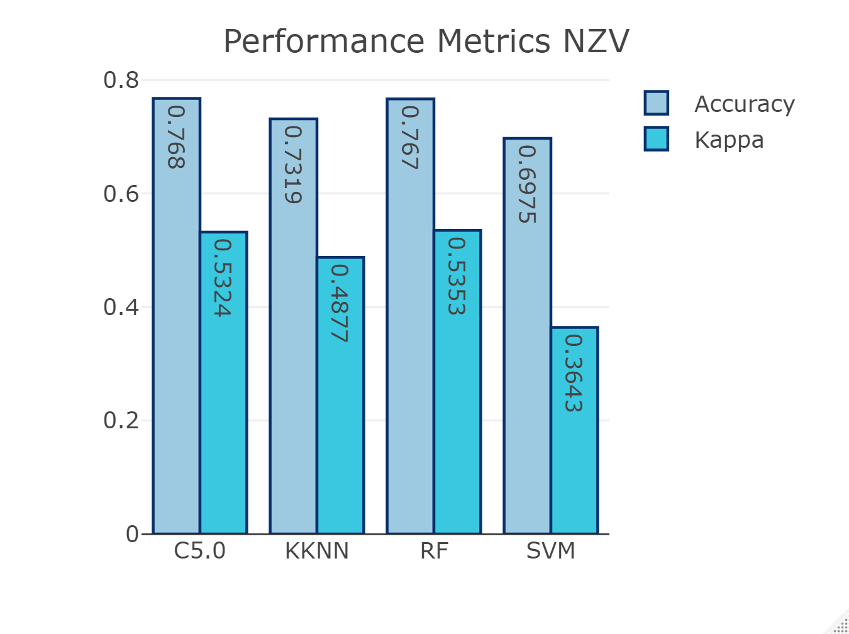

Next, I used a packaged procedure that provides a statistical recommendation of which attributes to exclude from the data set, as deemed to have little impact on the outcome , called Recursive Feature Elimination. For the Galaxy small data set with attributes removed based on the RFE processes, I achieved better than 76% accuracy with over 53% confidence with the C5.0 algorithm.
Galaxy RFE Results
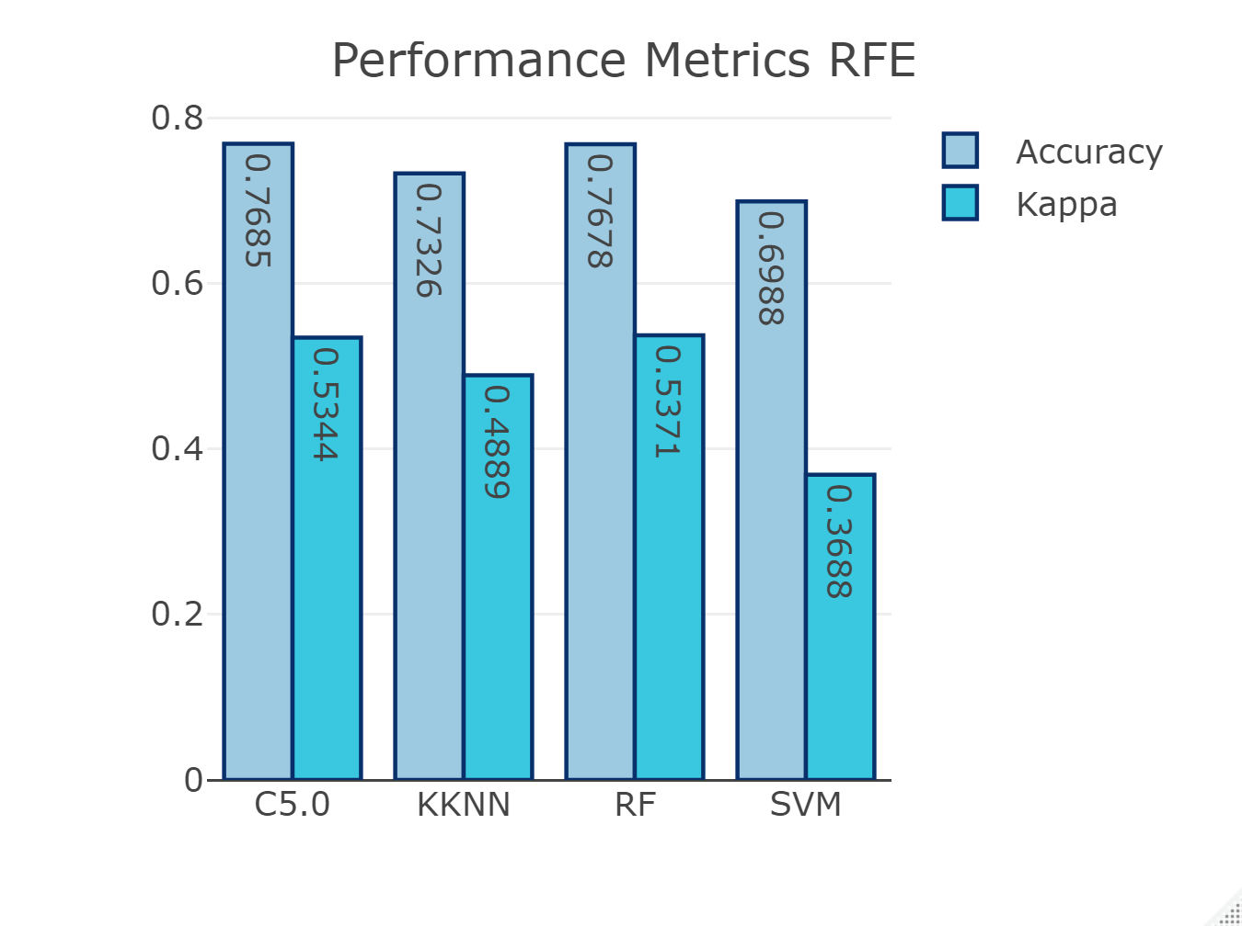

For the first three attempts, the best outcome was produced with the RFE data set processed through the C5.0 algorithm – but just barely!
C5.0 with galaxydfoobf dataset
Accuracy Kappa
0.768 0.5324
C5.0 with galaxyNZVf dataset
Accuracy Kappa
0.768 0.5324
C50 with galaxyRFEf dataset
Accuracy Kappa
0.7685 0.5344

Next I tried to see if I could improve performance by combining the sentiment results and reducing the number of possible outcomes so that 0 & 1 are combined to 1, and 4 & 5 are combined to 4. I ran the best performing model above for Galaxy, the C5.0 algorithm. The outcome for this dataset was considerably better with an 85% accuracy rate and a higher level of confidence in outcomes.
Accuracy Kappa
0.8473657 0.6038792
I ran one final test to see if I could come up with a better outcome. With another technical called Principal Component Analysis, I came us with about 10% accuracy. This is far less than the other tests. So, I discarded this one altogether.
So, for the Galaxy sentiment analysis modeling I chose the C5.0 algorithm run on out of the box data combining 0 &1 and 4 & 5 ratings, yielding the best outcomes.
I used this algorithm configuration on the large data set and found the following:
First, the distribution of ratings when combined simply increased the two ends of the spectrum – more that are basically negative (1) and more that area basically positive (4).

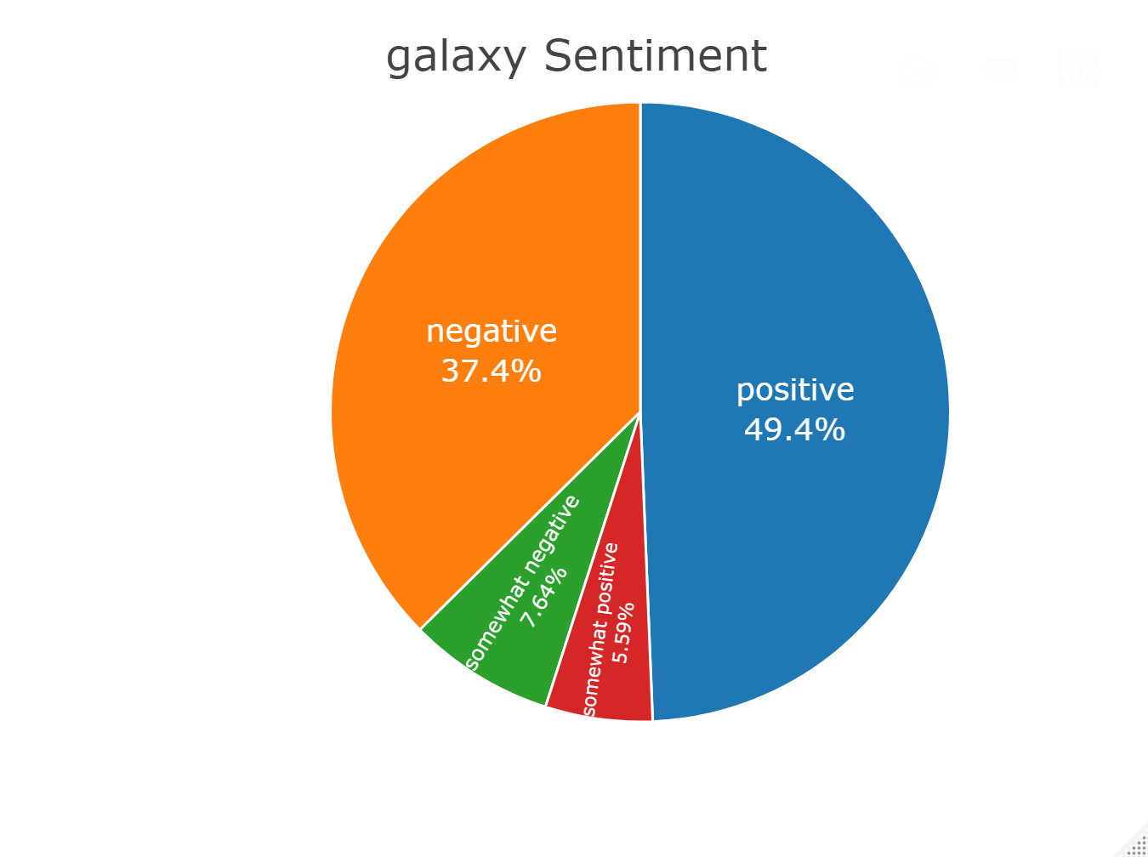

With about 55% positive sentiment, Galaxy proves to be a really solid product, when I used the model on the unseen data, with about 60% confidence in these figures. It’s very interesting that the training data set appeared to slant very strongly to a very overwhelmingly positive sentiment about Galaxy phones, but with the unseen large matrix data set it was less so.
======================================================================
Iphone Sentiment Analysis Results
I took the exact same approach to the iphone data as the Galaxy data.
Out of the box distribution for iPhones is interesting. The distribution of sentiment results suggest a generally favorable opinion of the iPhone with far more (58% strongly positive – 5) versus not a favorable opinion (15% strongly negative). Since the results are skewed so far to the left or right, we can conclude the sentiments 1-4, while important are low in magnitude, relatively speaking – so on the whole, people really like the iPhone products based on the training data set.
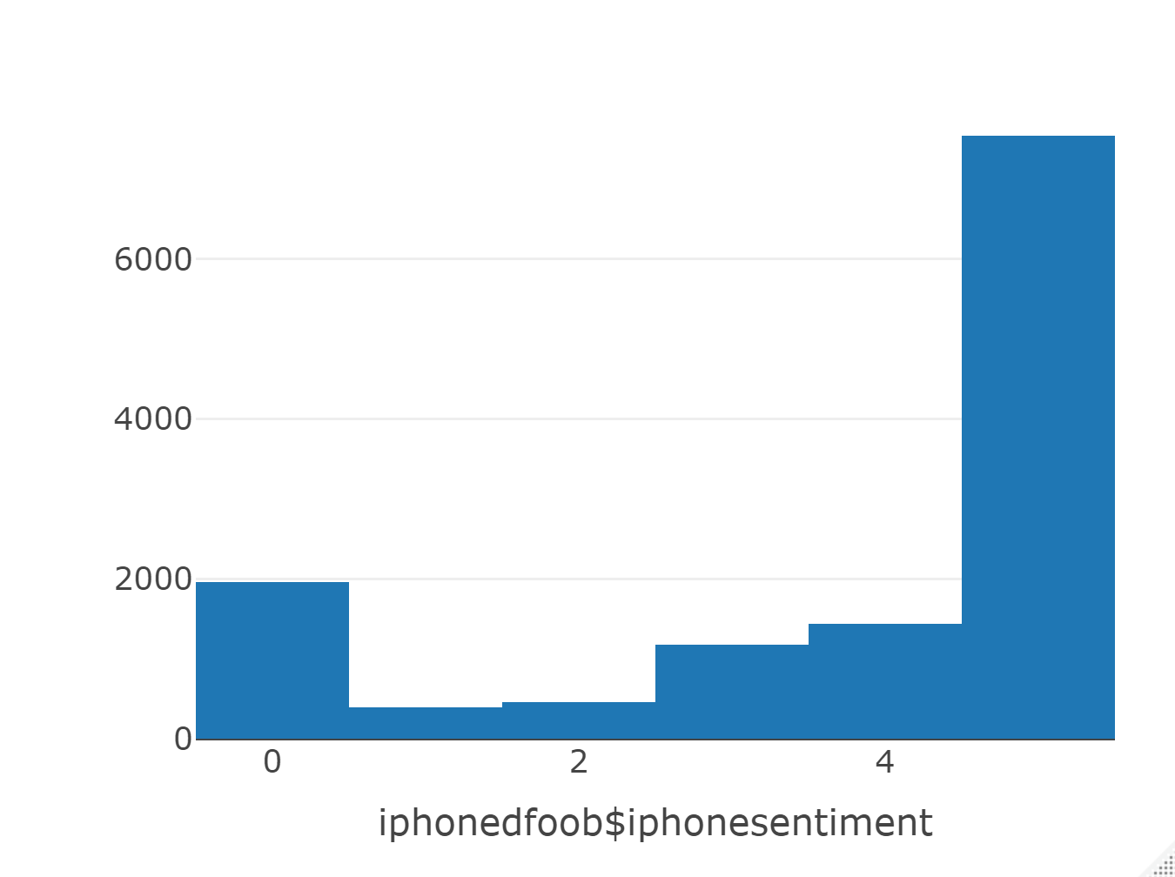

Using this information, I ran the out of the box data set for the iPhone sentiment analysis researched by your team, and referred to as the small matrix data set evaluating, to see whether or not I can generate a reliable algorithm for sentiment prediction on a much larger data set. Out of the box, I was able to achieve better than 77% accuracy, with an average level of confidence in that result with the RF (Random Forest) algorithm.
iPhone Out of the Box Results:
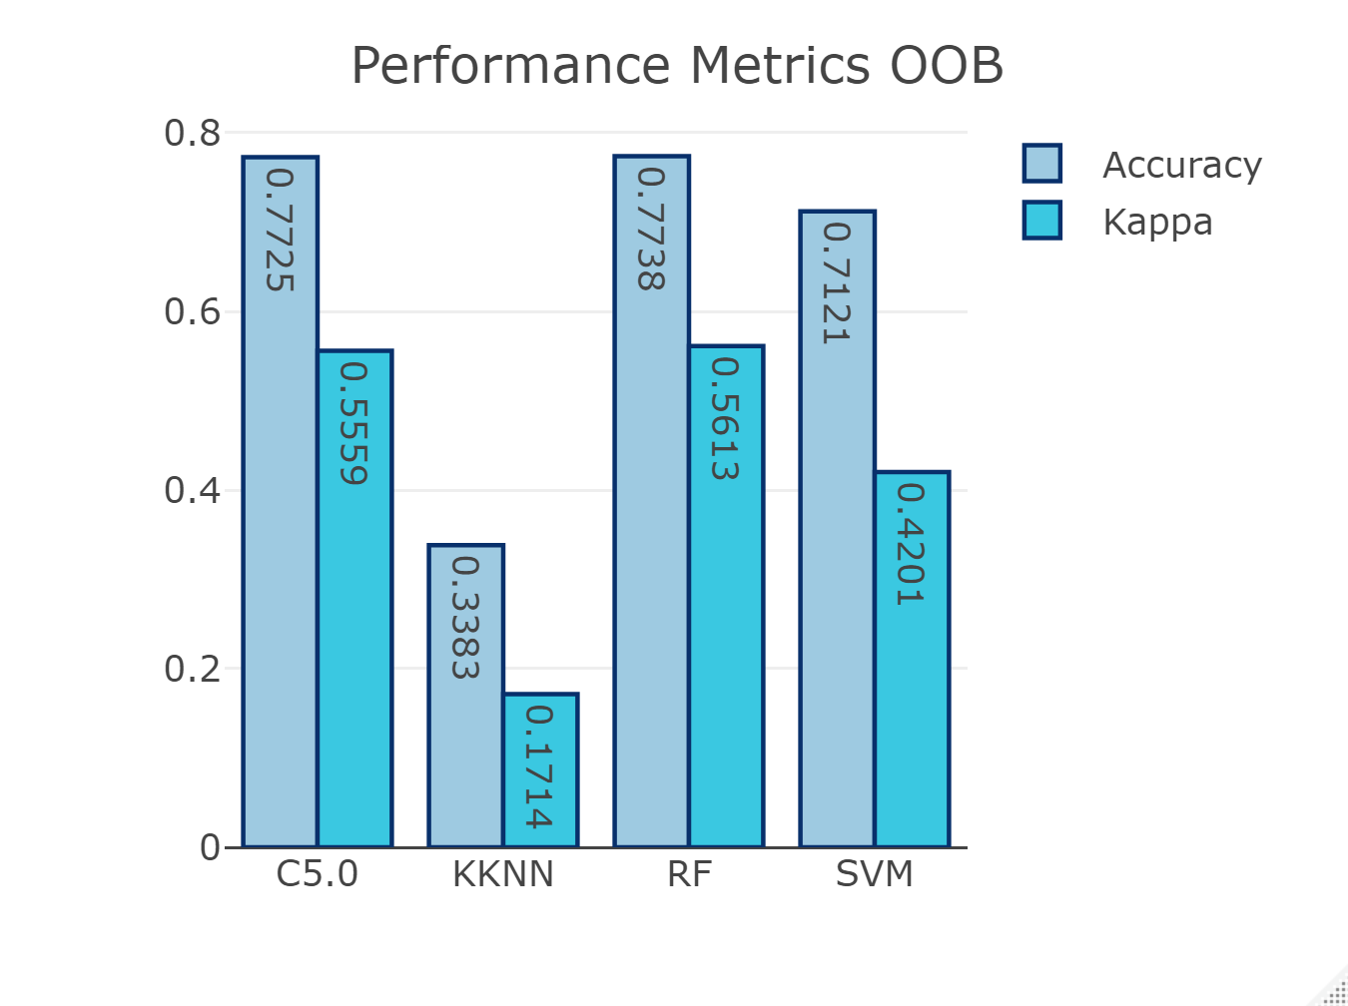

Next, I the manipulated the data by removing all attributes with near zero variance, meaning there was very little impact these attributes should have on the outcome. Removing these attributes from the calculation improves perfromance and ensures there is no needless impact, even small, from attributes that are deemed to statistically have little to no impact of the outcome.
Running the same four machine learning algorithms on the iphone small data set with attributes with near zero variance yielded a 76% accuracy with confidence above 53% with the same algorithm, C5.0
iPhone NZV Results
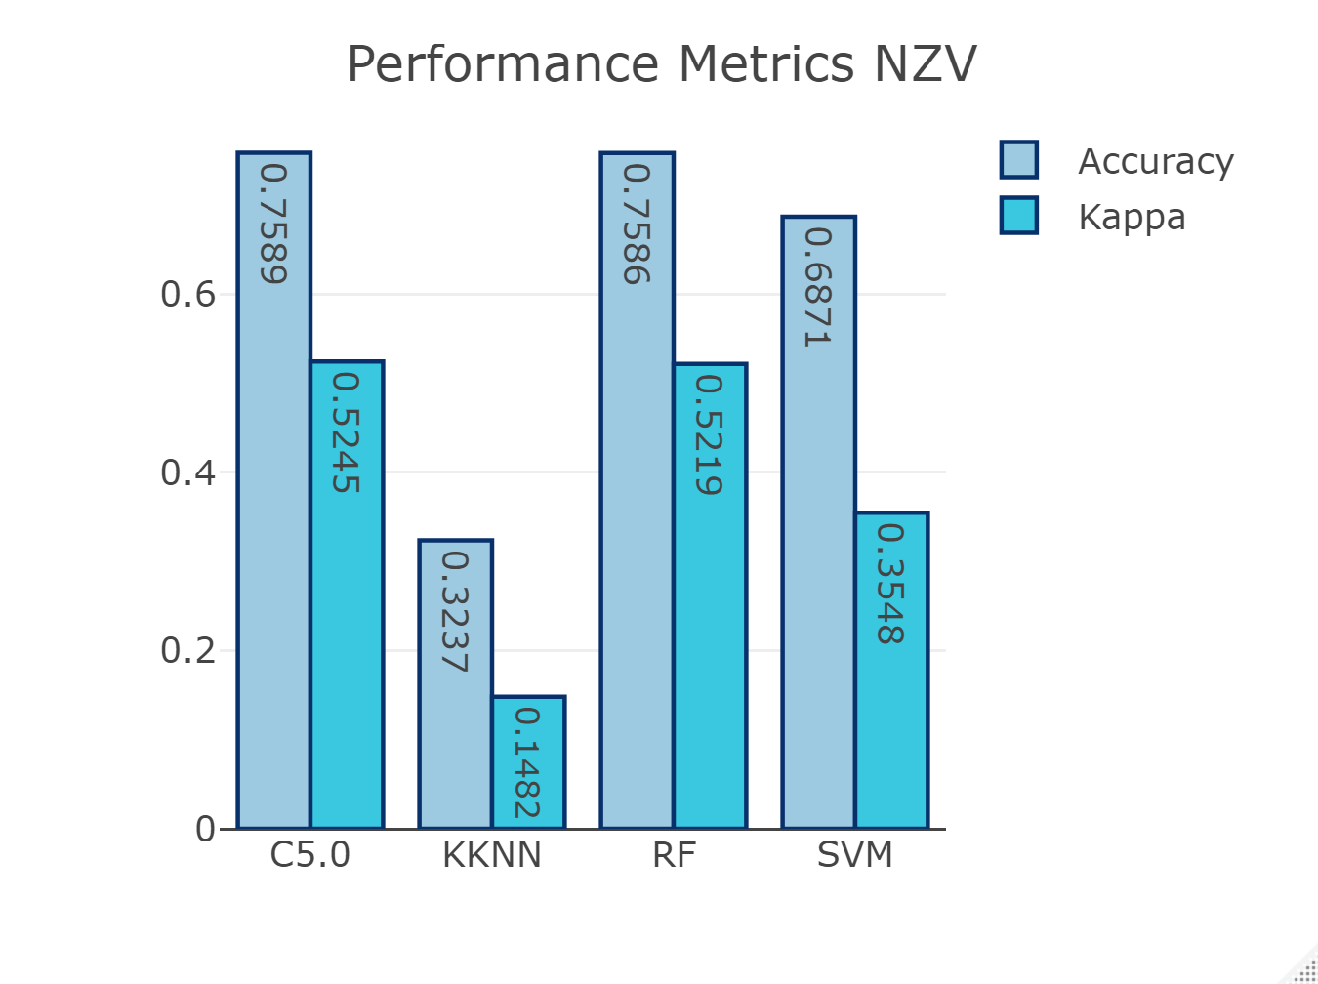

Next, I used a packaged procedure that provides a statistical recommendation of which attributes to exclude from the data set, as deemed to have little impact on the outcome , called Recursive Feature Elimination. For the iPhone small data set with attributes removed based on the RFE processes, I achieved better than 77% accuracy with over 56% confidence with the RF algorithm.
iPhone RFE Results
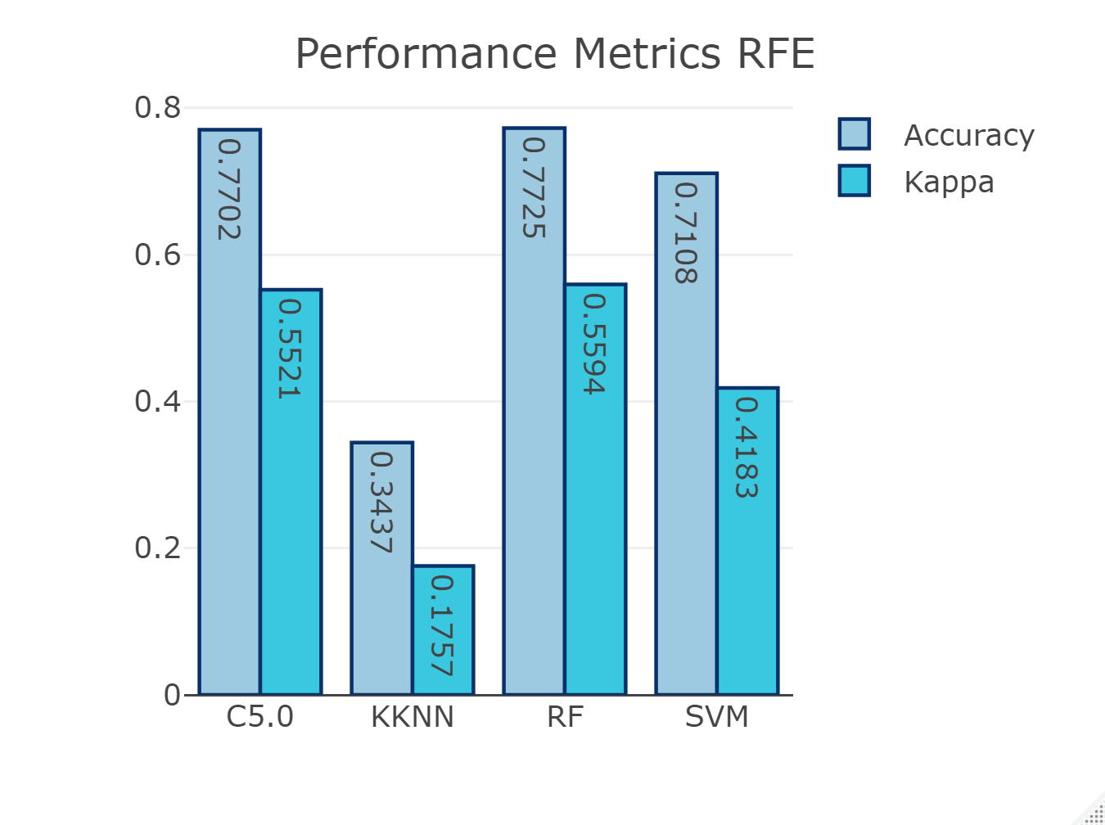

For the first three attempts, the best outcome was produced with the out of the box data set processed through the Random Forest (RF) algorithm – but just barely!
RF with iphonedfoobf dataset
Accuracy Kappa
0.7738 0.5613
C5.0 with iphoneNZVf dataset
Accuracy Kappa
0.7589 0.5245
RF with iphoneRFEf dataset
Accuracy Kappa
0.7725 0.5594

Next I tried to see if I could improve performance by combining the sentiment results and reducing the number of possible outcomes so that 0 & 1 are combined to 1, and 4 & 5 are combined to 4. I ran the best performing model above for iPhone, the RF algorithm. The outcome for this dataset was considerably better with an 99% accuracy rate and a higher level of confidence in outcomes.
Accuracy Kappa
0.9863753 0.9715681
I ran one final test to see if I could come up with a better outcome. With another technical called Principal Component Analysis, I came us with about 76% accuracy. This is less than the other tests. So, I discarded this one altogether.
So, for the iPhone sentiment analysis modeling I chose the RF algorithm run on out of the box data combining 0 &1 and 4 & 5 ratings, yielding the best outcomes.
I used this algorithm configuration on the large data set and found the following:
First, the distribution of ratings when combined simply increased the two ends of the spectrum – more that are basically negative (1) and more that area basically positive (4).
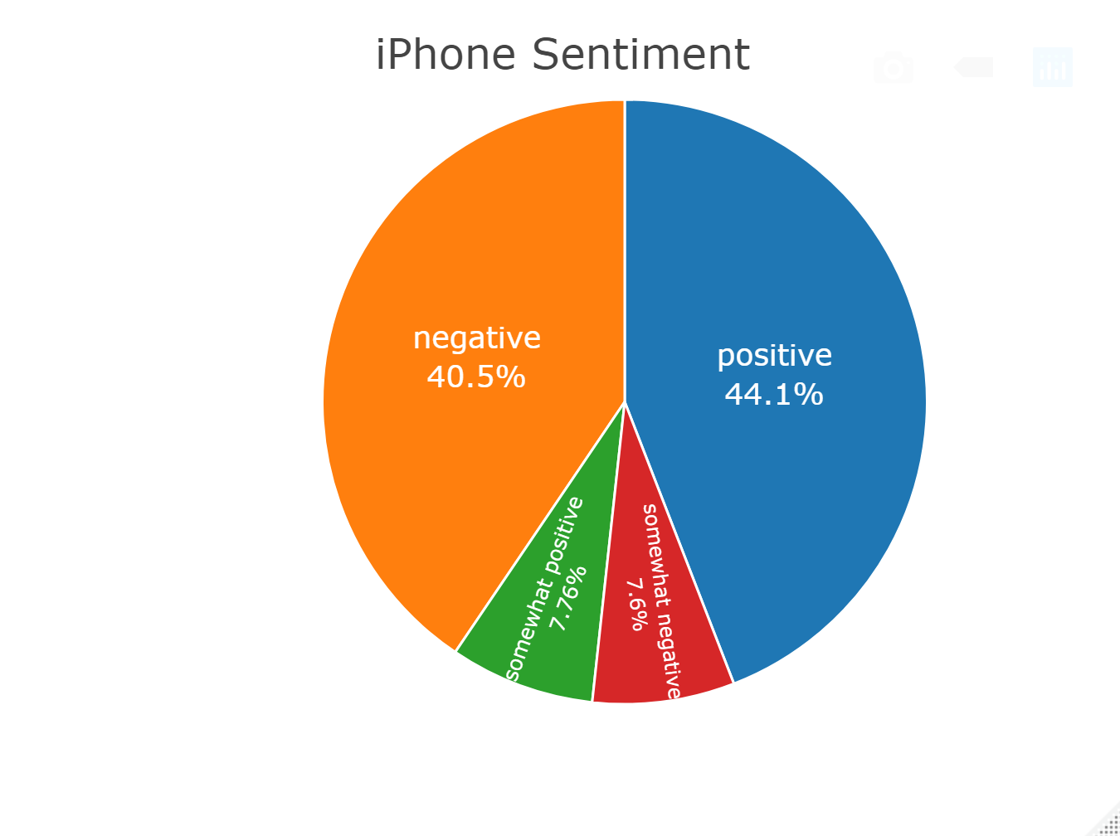

=======================================================================
Conclusion

The iPhone appears to more closely split down the middle in sentiment with almost 50% positive and 50% negative AND very close to similar percentages of positive and negative values for 1 and 4 only. So, compared to Galaxy, the iPhone is more closely polarized evenly as half love it and half hate it. But on the whole the results for the iPhone are not widely different than those for the Galaxy. Plus, since both experienced better predictive results when I combined negative (0 &1) and positive (4 &5) ratings, I could create a fairly similar comparison
While the outcome of the analysis did not yield a really clear and dominant leader in the market, at least relative to sentiment analysis, based on this analysis, I recommend going with the Samsung phone for your application platform.
Considerations for Future Analysis
There are possibly a few things you could consider adding into this analysis. To help drive to a clearer winner, you could research the market share of each of these phones in your target market. You could use the percentage of market share in the medical industry, for instance, as a weight to use to multiple each outcome above. If market share is very different, you could end up with one phone coming out ahead more strongly. If they are close in market share in the target market, then the results will be similar to the conclusions here.
The team might also consider expanding the vocabulary describing a positive or negative response as well as the vocabulary used to identify mentions of the products on web pages. This might provide a richer set of data, but at a cost for performance of the algorithms and possibly the complexity of the analysis.
Finally, the team could pull more observations from Common Crawl. While you may run into an economies of scale and diminishing returns economics for performance and results, increasing the observation set might provide better insight – or better results from a predictive algorithm.

